1. 請撰寫GA計算下列函數的最大值

> max(max_Gen_value)

[1] 3003.202

Code:

N_size <- 30

N_bit <- 8

Gen <- 30

Population <- matrix(sample(c(0,1), size = N_size*N_bit, replace = T), N_size, N_bit)

mut_freq <- 0.05

Po_value <- 8*Population[,1] + 4*Population[,2] + 2*Population[,3] + 1*

Population[,4] + 1/2*Population[,5] + 1/4*Population[,6] +1/8*Population[,7] + 1/16*Population[,8]

Po_value <- Po_value - 8

fit <- function(x){

2*x^3 - 25*x^2 + 18*x + 3000 - x*sin(x)

}

fit_value <- fit(Po_value)

idx <- 1:N_size

max_Gen_value <- rep(0, Gen)

max_Gen_value[1] <- max(fit_value)

max_Gen_ind <- matrix(0, Gen, N_bit)

max_Gen_ind[1,] <- Population[which(fit_value == max(fit_value))[1],]

max_Gen_Po_value <- rep(0, Gen)

max_Gen_Po_value[1] <- Po_value[which(fit_value == max(fit_value))[1]]

for(now_Gen in 2:Gen){

child <- matrix(0, N_size, N_bit)

child[1,] <- Population[which(fit_value == max(fit_value))[1],]

switch_bit <- sample(N_bit, 1)

child[2,] <- child[1,]

child[2, switch_bit:N_bit] <- !child[2, switch_bit:N_bit]

child_size <- 2

total_wheel <- sum(fit_value)

select_frequency <- fit_value/total_wheel

while(child_size < N_size){

P_idx <- sample(idx, size = 2, replace = F, prob = select_frequency)

P1 <- Population[P_idx[1],]

P2 <- Population[P_idx[2],]

switch_bit <- sample(N_bit, 2)

switch_bit <- sort(switch_bit)

P1_new <- P1

P1_new[switch_bit[1]:switch_bit[2]] <- P2[switch_bit[1]:switch_bit[2]]

P2_new <- P2

P2_new[switch_bit[1]:switch_bit[2]] <- P1[switch_bit[1]:switch_bit[2]]

if(runif(1, 0, 1) < mut_freq){

tar_bit <- sample(N_bit,1)

P1_new[tar_bit] <- !P1_new[tar_bit]

}

if(runif(1, 0, 1) < mut_freq){

tar_bit <- sample(N_bit,1)

P2_new[tar_bit] <- !P2_new[tar_bit]

}

child[child_size + 1,] <- P1_new

child[child_size + 2,] <- P2_new

child_size <- child_size + 2

}

Population <- child

Po_value <- 8*Population[,1] + 4*Population[,2] + 2*Population[,3] + 1*Population[,4] + 1/2*Population[,5] + 1/4*Population[,6] +1/8*Population[,7] + 1/16*Population[,8]

Po_value <- Po_value - 8

fit_value <- fit(Po_value)

max_Gen_value[now_Gen] <- max(fit_value)

max_Gen_Po_value[now_Gen] <- Po_value[which(fit_value == max(fit_value))[1]]

max_Gen_ind[now_Gen,] <- Population[which(fit_value == max(fit_value))[1],]

}

max(max_Gen_value)

1. 請重複跑你的程式碼1000次，比較每次結果是否相同

幾乎所有結果都有收斂到最佳解，即3003.202。

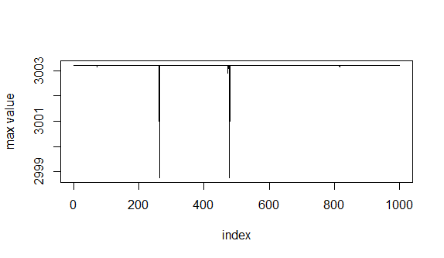

Code: ans1000 <- c()

for(i in 1:1000){

N_size <- 30

N_bit <- 8

Gen <- 30

Population <- matrix(sample(c(0,1), size = N_size*N_bit, replace = T), N_size, N_bit)

mut_freq <- 0.05

Po_value <- 8*Population[,1] + 4*Population[,2] + 2*Population[,3] + 1*

Population[,4] + 1/2*Population[,5] + 1/4*Population[,6] +1/8*Population[,7] + 1/16*Population[,8]

Po_value <- Po_value - 8

fit <- function(x){

2*x^3 - 25*x^2 + 18*x + 3000 - x*sin(x)

}

fit_value <- fit(Po_value)

idx <- 1:N_size

max_Gen_value <- rep(0, Gen)

max_Gen_value[1] <- max(fit_value)

max_Gen_ind <- matrix(0, Gen, N_bit)

max_Gen_ind[1,] <- Population[which(fit_value == max(fit_value))[1],]

max_Gen_Po_value <- rep(0, Gen)

max_Gen_Po_value[1] <- Po_value[which(fit_value == max(fit_value))[1]]

for(now_Gen in 2:Gen){

child <- matrix(0, N_size, N_bit)

child[1,] <- Population[which(fit_value == max(fit_value))[1],]

switch_bit <- sample(N_bit, 1)

child[2,] <- child[1,]

child[2, switch_bit:N_bit] <- !child[2, switch_bit:N_bit]

child_size <- 2

total_wheel <- sum(fit_value)

select_frequency <- fit_value/total_wheel

while(child_size < N_size){

P_idx <- sample(idx, size = 2, replace = F, prob = select_frequency)

P1 <- Population[P_idx[1],]

P2 <- Population[P_idx[2],]

switch_bit <- sample(N_bit, 2)

switch_bit <- sort(switch_bit)

P1_new <- P1

P1_new[switch_bit[1]:switch_bit[2]] <- P2[switch_bit[1]:switch_bit[2]]

P2_new <- P2

P2_new[switch_bit[1]:switch_bit[2]] <- P1[switch_bit[1]:switch_bit[2]]

if(runif(1, 0, 1) < mut_freq){

tar_bit <- sample(N_bit,1)

P1_new[tar_bit] <- !P1_new[tar_bit]

}

if(runif(1, 0, 1) < mut_freq){

tar_bit <- sample(N_bit,1)

P2_new[tar_bit] <- !P2_new[tar_bit]

}

child[child_size + 1,] <- P1_new

child[child_size + 2,] <- P2_new

child_size <- child_size + 2

}

Population <- child

Po_value <- 8*Population[,1] + 4*Population[,2] + 2*Population[,3] + 1*Population[,4] + 1/2*Population[,5] + 1/4*Population[,6] +1/8*Population[,7] + 1/16*Population[,8]

Po_value <- Po_value - 8

fit_value <- fit(Po_value)

max_Gen_value[now_Gen] <- max(fit_value)

max_Gen_Po_value[now_Gen] <- Po_value[which(fit_value == max(fit_value))[1]]

max_Gen_ind[now_Gen,] <- Population[which(fit_value == max(fit_value))[1],]

}

ans1000[i] <- max(max_Gen_value)

}

plot(ans1000, type="l", xlab = "index", ylab = "max value")

1. 請生成10, 30, 50個個體比較結果是否有影響

個體數越多的 GA 能越快達到收斂值。

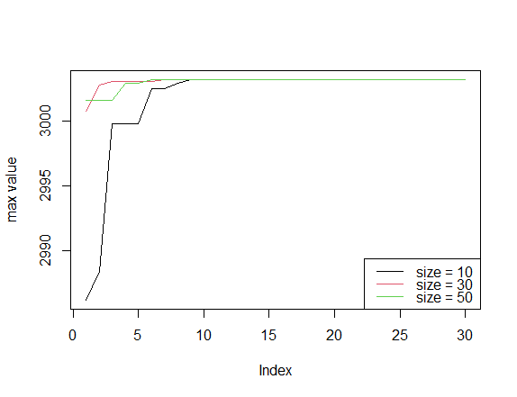

Code:

size <- c(10, 30, 50)

repeat_max <- list()

for(i in 1:3){

N_size <- size[i]

N_bit <- 8

Gen <- 30

Population <- matrix(sample(c(0,1), size = N_size*N_bit, replace = T), N_size, N_bit)

mut_freq <- 0.05

Po_value <- 8*Population[,1] + 4*Population[,2] + 2*Population[,3] + 1*

Population[,4] + 1/2*Population[,5] + 1/4*Population[,6] +1/8*Population[,7] + 1/16*Population[,8]

Po_value <- Po_value - 8

fit <- function(x){

2*x^3 - 25*x^2 + 18*x + 3000 - x*sin(x)

}

fit_value <- fit(Po_value)

idx <- 1:N_size

max_Gen_value <- rep(0, Gen)

max_Gen_value[1] <- max(fit_value)

max_Gen_ind <- matrix(0, Gen, N_bit)

max_Gen_ind[1,] <- Population[which(fit_value == max(fit_value))[1],]

max_Gen_Po_value <- rep(0, Gen)

max_Gen_Po_value[1] <- Po_value[which(fit_value == max(fit_value))[1]]

for(now_Gen in 2:Gen){

child <- matrix(0, N_size, N_bit)

child[1,] <- Population[which(fit_value == max(fit_value))[1],]

switch_bit <- sample(N_bit, 1)

child[2,] <- child[1,]

child[2, switch_bit:N_bit] <- !child[2, switch_bit:N_bit]

child_size <- 2

total_wheel <- sum(fit_value)

select_frequency <- fit_value/total_wheel

while(child_size < N_size){

P_idx <- sample(idx, size = 2, replace = F, prob = select_frequency)

P1 <- Population[P_idx[1],]

P2 <- Population[P_idx[2],]

switch_bit <- sample(N_bit, 2)

switch_bit <- sort(switch_bit)

P1_new <- P1

P1_new[switch_bit[1]:switch_bit[2]] <- P2[switch_bit[1]:switch_bit[2]]

P2_new <- P2

P2_new[switch_bit[1]:switch_bit[2]] <- P1[switch_bit[1]:switch_bit[2]]

if(runif(1, 0, 1) < mut_freq){

tar_bit <- sample(N_bit,1)

P1_new[tar_bit] <- !P1_new[tar_bit]

}

if(runif(1, 0, 1) < mut_freq){

tar_bit <- sample(N_bit,1)

P2_new[tar_bit] <- !P2_new[tar_bit]

}

child[child_size + 1,] <- P1_new

child[child_size + 2,] <- P2_new

child_size <- child_size + 2

}

Population <- child

Po_value <- 8*Population[,1] + 4*Population[,2] + 2*Population[,3] + 1*Population[,4] + 1/2*Population[,5] + 1/4*Population[,6] +1/8*Population[,7] + 1/16*Population[,8]

Po_value <- Po_value - 8

fit_value <- fit(Po_value)

max_Gen_value[now_Gen] <- max(fit_value)

max_Gen_Po_value[now_Gen] <- Po_value[which(fit_value == max(fit_value))[1]]

max_Gen_ind[now_Gen,] <- Population[which(fit_value == max(fit_value))[1],]

}

repeat_max[[i]] <- max_Gen_value

}

plot(repeat_max[[1]], type = "l", col = 1, ylab = "max value")

lines(repeat_max[[2]], type = "l", col = 2)

lines(repeat_max[[3]], type = "l", col = 3)

legend("bottomright",lty = 1, col = c(1,2,3), legend = c("size = 10", "size = 30", "size = 50"))

1. 請生成代數10, 30, 50比較結果是否有影響

影響不大，因為通常在前 5 世代就已經收斂，不過世代數越大依然越有可能達到收斂值。

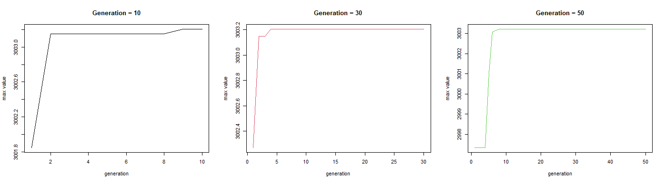

Code:

##4

Gen_set <- c(10, 30, 50)

N_size <- 30

N_bit <- 8

repeat_max <- list()

for(k in 1:3){

Gen <- Gen_set[k]

Population <- matrix(sample(c(0,1), size = N_size*N_bit, replace = T),N_size, N_bit)

mut_freq <- 0.05

Po_value <- 8*Population[,1] + 4*Population[,2] + 2*Population[,3] +1*Population[,4] + 1/2*Population[,5] + 1/4*Population[,6] +1/8*Population[,7] + 1/16*Population[,8]

Po_value <- Po_value - 8

fit <- function(x){

2*x^3 - 25*x^2 + 18*x + 3000 - x*sin(x)

}

fit_value <- fit(Po_value)

idx <- 1:N_size

max_Gen_value <- rep(0, Gen)

max_Gen_value[1] <- max(fit_value)

max_Gen_ind <- matrix(0, Gen, N_bit)

max_Gen_ind[1,] <- Population[which(fit_value == max(fit_value))[1],]

max_Gen_Po_value <- rep(0, Gen)

max_Gen_Po_value[1] <- Po_value[which(fit_value == max(fit_value))[1]

]

for(now_Gen in 2:Gen){

child <- matrix(0, N_size, N_bit)

child[1,] <- Population[which(fit_value == max(fit_value))[1],]

switch_bit <- sample(N_bit, 1)

child[2,] <- child[1,]

child[2, switch_bit:N_bit] <- !child[2, switch_bit:N_bit]

child_size <- 2

total_wheel <- sum(fit_value)

select_frequency <- fit_value/total_wheel

while(child_size < N_size){

P_idx <- sample(idx, size = 2, replace = F, prob = select_frequency)

P1 <- Population[P_idx[1],]

P2 <- Population[P_idx[2],]

switch_bit <- sample(N_bit, 2)

switch_bit <- sort(switch_bit)

P1_new <- P1

P1_new[switch_bit[1]:switch_bit[2]] <- P2[switch_bit[1]:switch_bit[2]]

P2_new <- P2

P2_new[switch_bit[1]:switch_bit[2]] <- P1[switch_bit[1]:switch_bit[2]]

if(runif(1, 0, 1) < mut_freq){

tar_bit <- sample(N_bit,1)

P1_new[tar_bit] <- !P1_new[tar_bit]

}

if(runif(1, 0, 1) < mut_freq){

tar_bit <- sample(N_bit,1)

P2_new[tar_bit] <- !P2_new[tar_bit]

}

child[child_size + 1,] <- P1_new

child[child_size + 2,] <- P2_new

child_size <- child_size + 2

}

Population <- child

Po_value <- 8*Population[,1] + 4*Population[,2] + 2*Population[,3] + 1*Population[,4] + 1/2*Population[,5] + 1/4*Population[,6] +1/8*Population[,7] + 1/16*Population[,8]

Po_value <- Po_value - 8

fit_value <- fit(Po_value)

max_Gen_value[now_Gen] <- max(fit_value)

max_Gen_Po_value[now_Gen] <- Po_value[which(fit_value == max(fit_value))[1]]

max_Gen_ind[now_Gen,] <- Population[which(fit_value == max(fit_value))[1],]

}

repeat_max[[k]] <- max_Gen_value

}

par(mfcol=c(1,3))

plot(repeat_max[[1]], type = "l", col = 1, main = "Generation = 10",

xlab = "generation", ylab = "max value")

plot(repeat_max[[2]], type = "l", col = 2, main = "Generation = 30",

xlab = "generation", ylab = "max value")

plot(repeat_max[[3]], type = "l", col = 3, main = "Generation = 50",

xlab = "generation", ylab = "max value")

1. 請改變突變機率0.05, 0.25, 0.5比較結果是否有影響

突變機率越高，在收斂前，越有可能有大幅度的成長(接近收斂值)，但也相對不穩定。

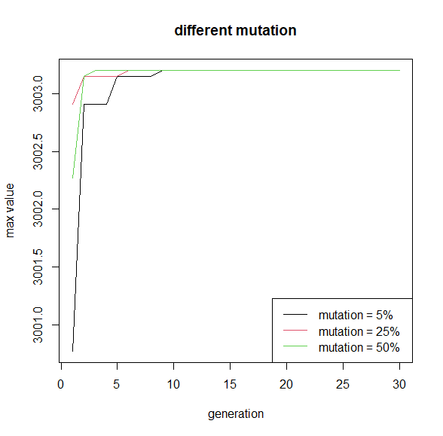

Code:

N_size <- 30

N_bit <- 8

Gen <- 30

mut_freq_set <- c(0.05, 0.25, 0.5)

repeat_max <- list()

for(k in 1:3){

mut_freq <- mut_freq_set[i]

Population <- matrix(sample(c(0,1), size = N_size*N_bit, replace = T), N_size, N_bit)

Po_value <- 8*Population[,1] + 4*Population[,2] + 2*Population[,3] + 1*Population[,4] + 1/2*Population[,5] + 1/4*Population[,6] +1/8*Population[,7] + 1/16*Population[,8]

Po_value <- Po_value - 8

fit <- function(x){

2*x^3 - 25*x^2 + 18*x + 3000 - x*sin(x)

}

fit_value <- fit(Po_value)

idx <- 1:N_size

max_Gen_value <- rep(0, Gen)

max_Gen_value[1] <- max(fit_value)

max_Gen_ind <- matrix(0, Gen, N_bit)

max_Gen_ind[1,] <- Population[which(fit_value == max(fit_value))[1],]

max_Gen_Po_value <- rep(0, Gen)

max_Gen_Po_value[1] <- Po_value[which(fit_value == max(fit_value))[1]

]

for(now_Gen in 2:Gen){

child <- matrix(0, N_size, N_bit)

child[1,] <- Population[which(fit_value == max(fit_value))[1],]

switch_bit <- sample(N_bit, 1)

child[2,] <- child[1,]

child[2, switch_bit:N_bit] <- !child[2, switch_bit:N_bit]

child_size <- 2

total_wheel <- sum(fit_value)

select_frequency <- fit_value/total_wheel

while(child_size < N_size){

P_idx <- sample(idx, size = 2, replace = F, prob = select_frequency)

P1 <- Population[P_idx[1],]

P2 <- Population[P_idx[2],]

switch_bit <- sample(N_bit, 2)

switch_bit <- sort(switch_bit)

P1_new <- P1

P1_new[switch_bit[1]:switch_bit[2]] <- P2[switch_bit[1]:switch_bit[2]]

P2_new <- P2

P2_new[switch_bit[1]:switch_bit[2]] <- P1[switch_bit[1]:switch_bit[2]]

if(runif(1, 0, 1) < mut_freq){

tar_bit <- sample(N_bit,1)

P1_new[tar_bit] <- !P1_new[tar_bit]

}

if(runif(1, 0, 1) < mut_freq){

tar_bit <- sample(N_bit,1)

P2_new[tar_bit] <- !P2_new[tar_bit]

}

child[child_size + 1,] <- P1_new

child[child_size + 2,] <- P2_new

child_size <- child_size + 2

}

Population <- child

Po_value <- 8*Population[,1] + 4*Population[,2] + 2*Population[,3] + 1*Population[,4] + 1/2*Population[,5] + 1/4*Population[,6] +1/8*Population[,7] + 1/16*Population[,8]

Po_value <- Po_value - 8

fit_value <- fit(Po_value)

max_Gen_value[now_Gen] <- max(fit_value)

max_Gen_Po_value[now_Gen] <- Po_value[which(fit_value == max(fit_value))[1]]

max_Gen_ind[now_Gen,] <- Population[which(fit_value == max(fit_value))[1],]

}

repeat_max[[k]] <- max_Gen_value

}

plot(repeat_max[[1]], type = "l", col = 1, xlab = "generation", ylab = "max value", main = "different mutation")

lines(repeat_max[[2]], type = "l", col = 2)

lines(repeat_max[[3]], type = "l", col = 3)

legend("bottomright",lty = 1, col = c(1,2,3), legend = c("mutation = 5%", "mutation = 25%", "mutation = 50%"))